Chinnakurchi
Geology
Type: Peninsular
Geomorphology
Landforms: Pediplain
Lithology
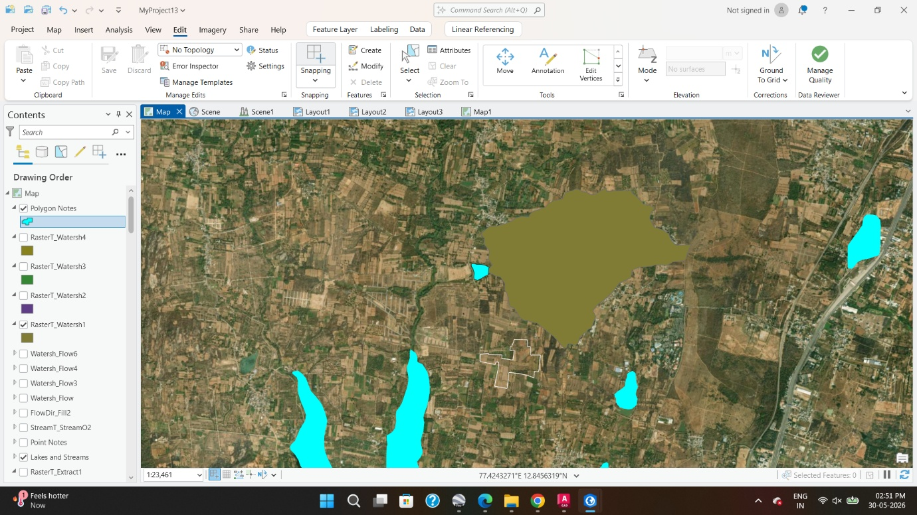
Type: Grey Hornblende

Lake Catchment : 467 Acres

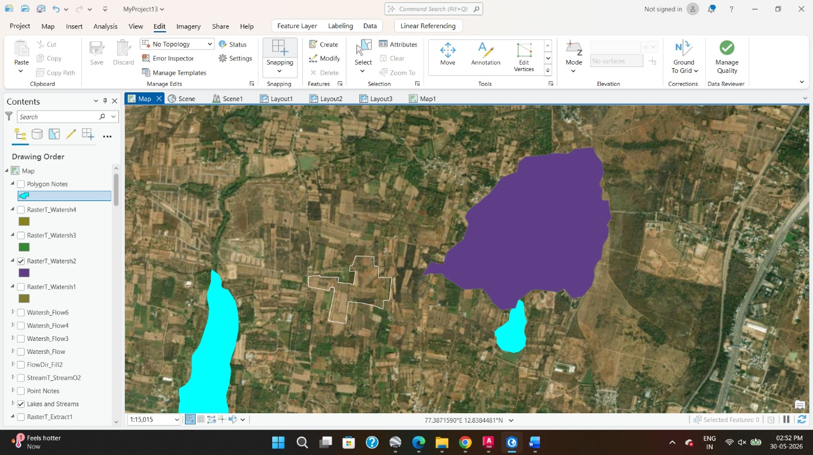

Lake Catchment : 250 Acres

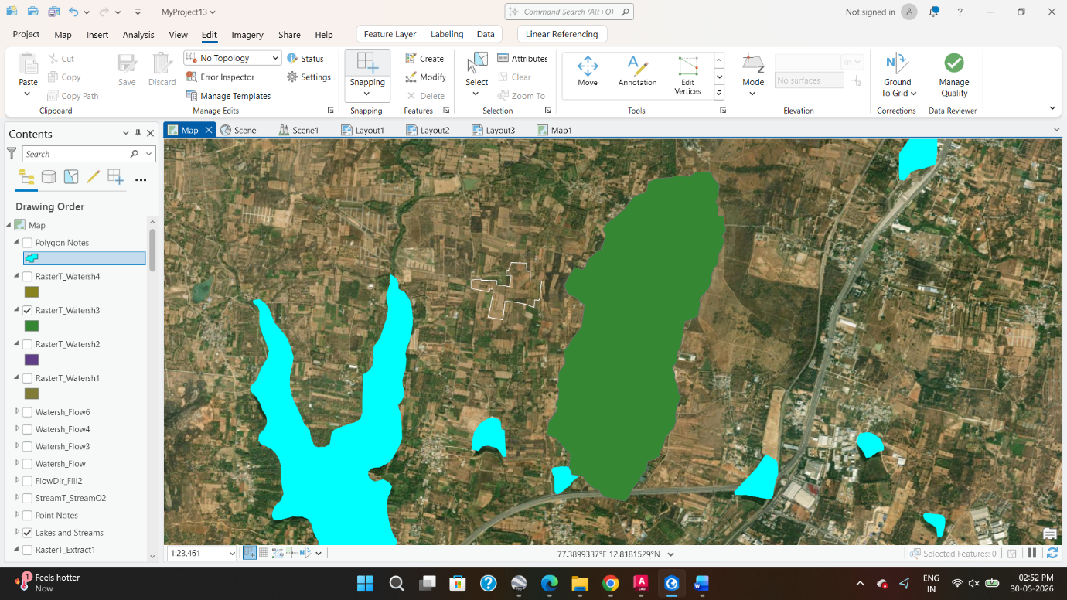

Lake Catchment : 657 Acres

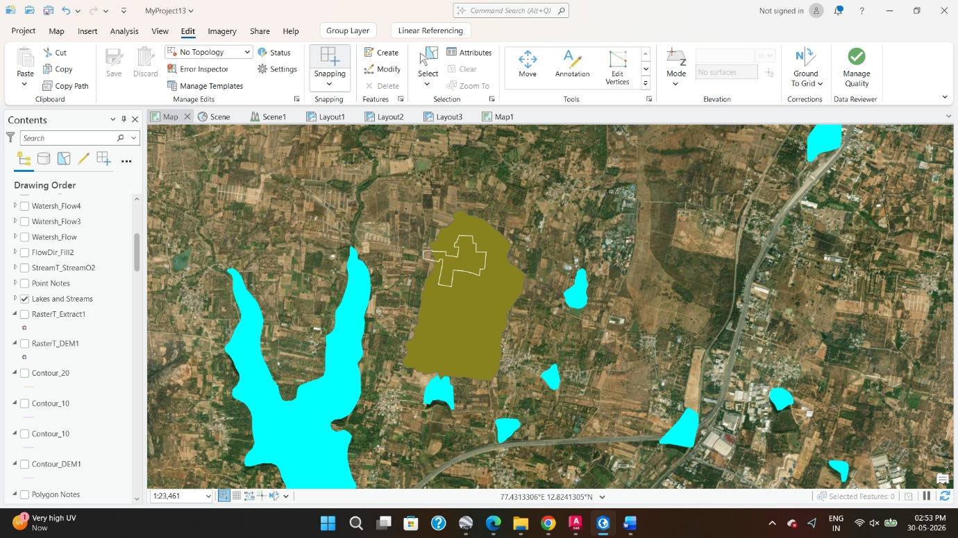
Lake Catchment : 320 Acres

